1970s and 1980s Videos & Activities
As the videos play, answer the questions that are posed. After assigned readings, complete the tasks that follow.
1970s Domestic Issues
- The Watergate Scandal:
  - What year did the scandal take place?

  - What are the Pentagon Papers?

  - Why would Nixon be upset these papers were sent to the media?

  - Why was the group called the Plumbers?

  - Explain why Nixon would want info from Ellsbury's psychiatrist.

  - What did the plumbers do at the Watergate hotel?

  - What evidence do we have to show that the plumbers were successful in imploding the Democratic party?

  - How did the Democrats do in the 1972 election?

  - Where was Nixon going to get this money to pay the plumbers?

  - How much would you expect if you were one of the burglars?

  - Who are the three people involved with the Washington Post story?

  - What happened with the Nixon tapes? Why couldn’t they be used in any trials?

- The Pardon of Nixon: http://www.history.com/topics/watergate/videos/ford-defends-nixon-pardon
  - Write two tweets illustrating your feelings if your president pardoned a criminal you wanted to see punished.

- The Oil Crisis
  - Have you experienced a fear of an energy crisis before? Compare your experiences with the ones illustrated in the clips.

  - What kind of impact will a crisis of this magnitude have on the country for the upcoming decade?

1970s Foreign Issues
- Détente
  - Why is Nixon’s visit to China so historic?

  - Why might some Americans support détente?

  - Why might some Americans oppose détente?

  - What are SALT talks?

- Iranian Hostage Crisis
  - After watching the clips and reading the passages, write your on brief diary entry as if you were one of the hostages:
_________________________________________________________________________________________________________________________________________________________________________________________________________________________________________________________________________________________________________________________________________________________________________________________________________________________________________________________________________________________________________________________________________________________________________________________________________________________________________________________________________________________________________________________________________________________________________________________________________________________________________________________________________________________________________________________________________________________________________________________________________________________________________________________________________________________________________________________________________________

The Reagan Era
- Reaganomics
  - Use the charts to determine if you believe “trickle-down” economics worked or not.
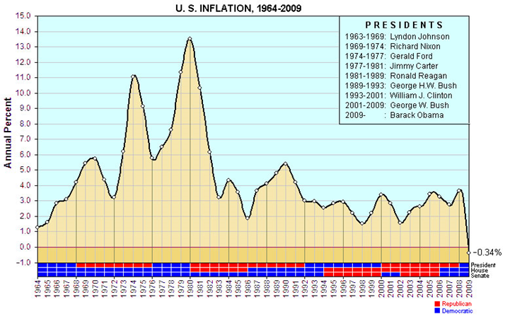
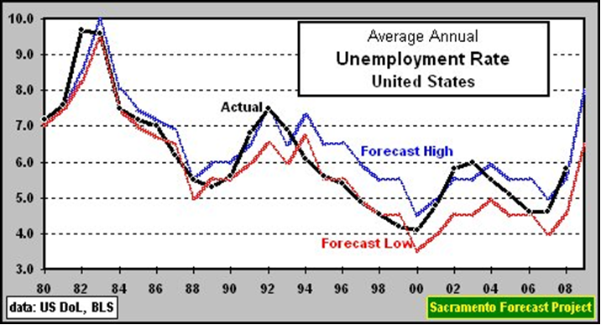

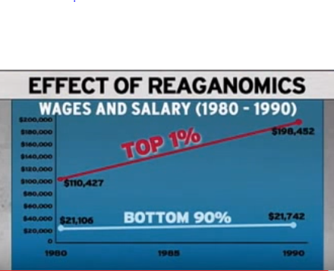

- Star Wars
  - Why did Reagan spend so much on defense? How did this fit into his economic plans as discussed previously?

  - Explain Reagan’s Strategic Defense Initiative.

  - How did this defense plan weaken the Soviets?

- Iran Contra Affair
  - Take notes on the video as it plays.

