Era: The Civil War Date: Name:
Questions (Form questions about the main ideas of each section of notes. Helpful hint: Questions could be based on interpreting, showing examples, cause and effect, summarizing the main idea, inferring a what if, etc.) | I can describe the advantages the Union had over the Confederacy.  Review  Differences Between North & South:  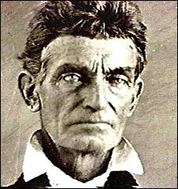  Abolition Movement:  - Harriet Tubman  - William Lloyd Garrison  - Harriet Beecher Stowe  - Frederick Douglas  - John Brown  Events Leading Up to Secession:  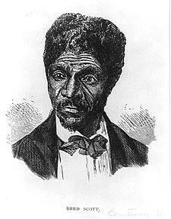  - Missouri Compromise  - Compromise of 1850  - Kansas-Nebraska Act  - The Dred Scott Decision  - Election of 1860  The Confederacy  The Civil War  The Union’s Advantages:  The Confederacy’s Advantages  Life During the War  The Emancipation Proclamation  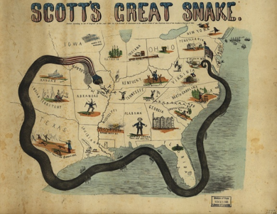  Your Anaconda Don’t Want None…of the North, that is.  Gettysburg  The Effects of the War:  North South
Summary (Summarize the main idea/s of the notes on this page into 1-2 statements. Helpful Hint: fit the main idea into a core theme.)

