Era: The Young Republic Date: Name:
Questions (Form questions about the main ideas of each section of notes. Helpful hint: Questions could be based on interpreting, showing examples, cause and effect, summarizing the main idea, inferring a what if, etc.) | I can explain how early presidents used the new powers of the federal government.  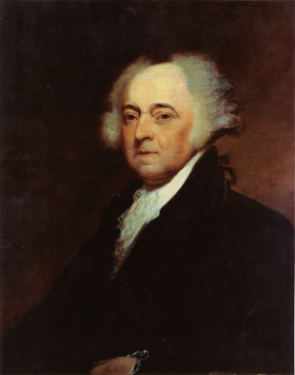  Washington’s Philosophy  John Adams  - Alien & Sedition Acts  - The Alien Part  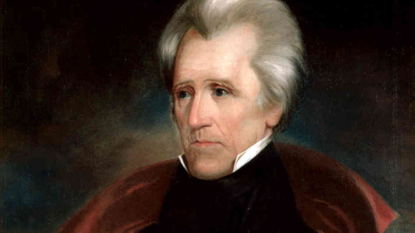  - The Sedition Part  Andrew Jackson  - Spoils System  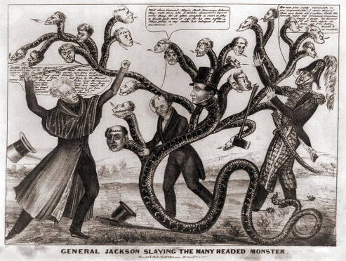  - The National Bank Issue  - Nullification
Summary (Summarize the main idea/s of the notes on this page into 1-2 statements. Helpful Hint: fit the main idea into a core theme.)

