Era: Date: Name:
Questions (Form questions about the main ideas of each section of notes. Helpful hint: Questions could be based on interpreting, showing examples, cause and effect, summarizing the main idea, inferring a what if, etc.) | I can explain why the US began Imperialistic practices in the early 1900s and how they did it.  Imperialism Defined:  Direct Imperialism  In-direct Imperialism  Expansionism  Why Imperialism???  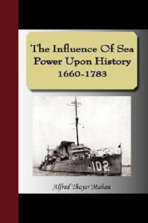  Naval Superiority  The Hawaiian Involvement  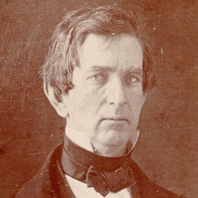  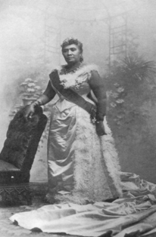  Alaskan Purchase  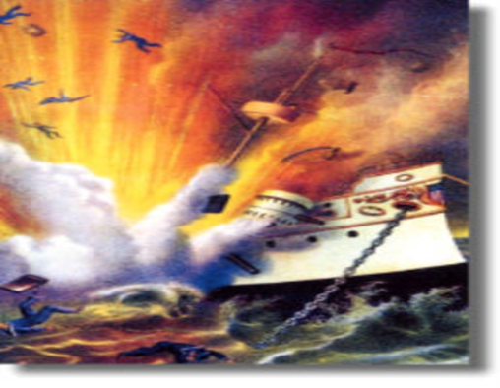  Spanish-American War  Cuba  U.S.S. Maine  Yellow Journalism  Rough Riders  “Splendid Little War”  Treaty of Paris #2 (1898)  Acquirements:  Platt Amendment:  Open Door Policy (China)  Boxer Rebellion  Signs of American Power:  - Monroe Doctrine & Roosevelt Corollary to Monroe Doctrine  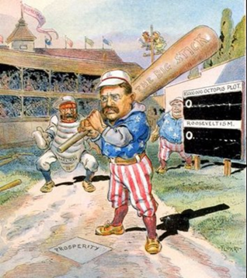  Big Stick Policy  - Treaty of Portsmouth –  - Panama Canal -
Summary (Summarize the main idea/s of the notes on this page into 1-2 statements. Helpful Hint: fit the main idea into a core theme.)

