Era: Date: Name:
Questions (Form questions about the main ideas of each section of notes. Helpful hint: Questions could be based on interpreting, showing examples, cause and effect, summarizing the main idea, inferring a what if, etc.) | I can describe the progressive efforts made by Presidents in the early 20th century.  Assassination of President William McKinley  Enter Teddy Roosevelt – “the accidental President”  Square Deal  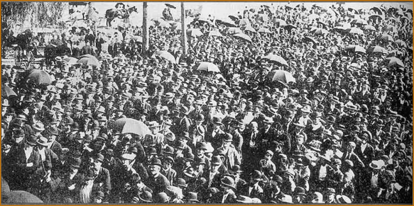  1902 Anthracite Coal Miners’ Strike  Trust – Busting  Good vs. Bad  Northern Securities Company  Hepburn Railroad Act  Consumer Protections  Pure Food and Drug Act  Meat Inspection Act  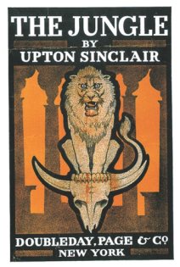  Conservation Efforts  William Howard Taft  Progressive Efforts:  Set-Backs to Progressivism  Angry TR  Election of 1912  4 Candidates / 4 Parties  Wilson’s New Freedom  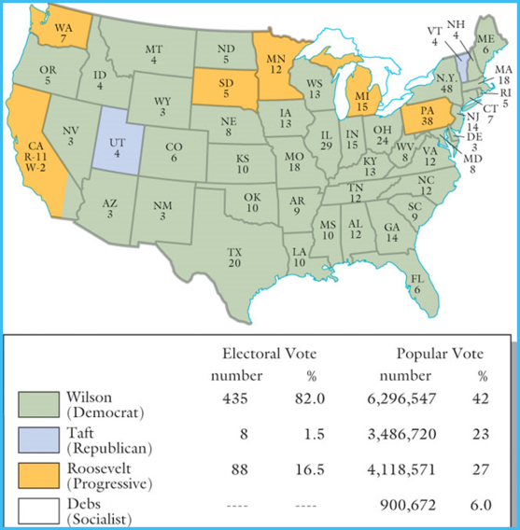  Federal Reserve Act  Federal Trade Commission Act  Clayton-Antitrust Act
Summary (Summarize the main idea/s of the notes on this page into 1-2 statements. Helpful Hint: fit the main idea into a core theme.)

