Era: Date: Name:
Questions (Form questions about the main ideas of each section of notes. Helpful hint: Questions could be based on interpreting, showing examples, cause and effect, summarizing the main idea, inferring a what if, etc.) | I can explain the 4 goals of the Progressive movement and discuss how these goals were attempted to be achieved.  Populism  Goals of the Progressive Movement (or Party)  Muckrakers  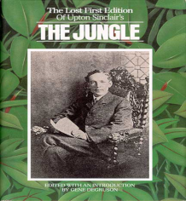  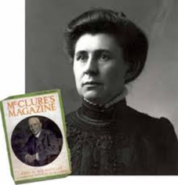  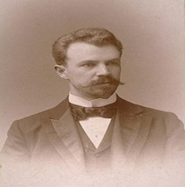  Efficiency Progressives  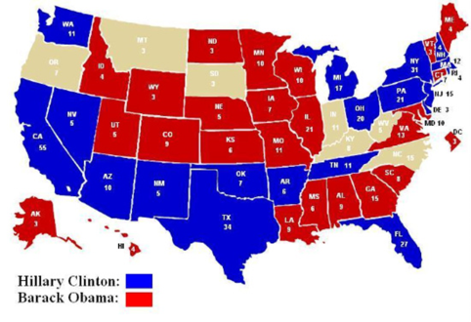  Wisconsin  - Recall  - Referendum  - Initiative  17th Amendment –  African American Life  Women’s Suffrage Movement  Seneca Falls Convention  19th Amendment –  Social Welfare Progressivism  - Crime  - Illiteracy  - Alcohol Abuse  Temperance  Prohibition  18th Amendment  - Child Labor  - Health & Safety  1911 NY Fire  Triangle Shirtwaist Factory Fire
Summary (Summarize the main idea/s of the notes on this page into 1-2 statements. Helpful Hint: fit the main idea into a core theme.)

