Era: Date: Name:
Questions (Form questions about the main ideas of each section of notes. Helpful hint: Questions could be based on interpreting, showing examples, cause and effect, summarizing the main idea, inferring a what if, etc.) | I can explain reasons American went to war in 1941 and what it was like at home during the war.  Causes of WWII  Hitler & His BFFLs  Appeasement  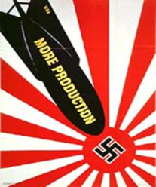  Production  Rationing  OPA -  Minorities During the War  CORE -  Tuskegee Airmen  Zoot Suit  Women in the War  Japanese Internment (much more on this next week)  Manhattan Project (much more on this next week)  Ending the War  Yalta Conference  Nuremburg Trials  G.I. Bill
Summary (Summarize the main idea/s of the notes on this page into 1-2 statements. Helpful Hint: fit the main idea into a core theme.)

