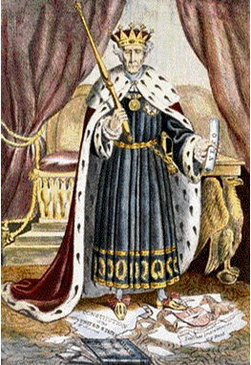
- How has the artist portrayed Andrew Jackson?
- Why do you believe the artist chose to depict him in this way?
- What is a presidential veto? (Use a dictionary if needed)
- What controversial action did President Jackson take in 1832-33 that is the subject of this cartoon?
- What items are in the cartoon that refer to the action in #4?
- Do you feel the artist supports President Jackson’s action? Why or why not?
- Should there be limits on presidential power beyond what is stated in the constitution? Why or why not?

