Mapping the Slave Compromises
Use your textbook and iPads (if needed) to locate, label and color the map appropriately. You will have a map quiz on much of this information on Friday, so pay attention to what is being labeled and what is being asked. Be sure to complete a key for each map.
The Missouri Compromise
- Label each state with a two-letter abbreviation
- Choose colors for the following categories and color them accordingly: (1) free states, (2) slave states, (3) free territory & (4) slave territory.
- Draw a solid line to represent the imaginary Missouri Compromise Line of 1820.
- Answer the following questions:
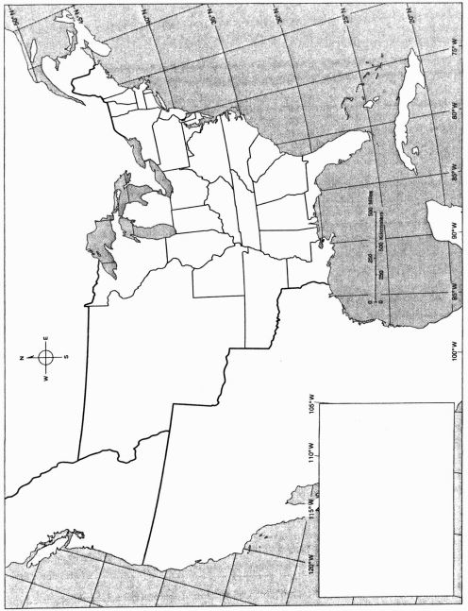
  - True or False – Pennsylvania was a free state in 1820
  - In 1818, who had the most power in the Senate? Free or slave states? What about the House of Representatives?

  - Was Florida Territory slave territory because it was south of the latitude 36 30?

  - True or False – Most of the Louisiana Purchase was south of the Missouri Compromise line.

The Compromise of 1850
- Label each state with a two-letter abbreviation
- Choose colors for the following categories and color them accordingly: (1) free states and territories in 1850; (2) slave states and territories in 1850; (3) territories open to slavery by popular sovereignty under the Compromise 'of 1850.
- Answer the following questions:
  - How many free states existed in 1850? How many slave states?

  - Which territories were affected by the Compromise of 1850? How were they affected?

  - How did the number of free states and slave states affect representation in Congress?

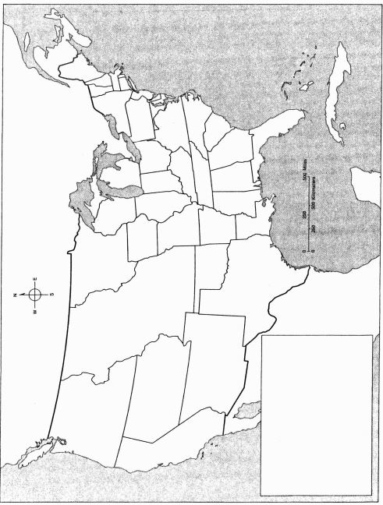

The Kansas-Nebraska Act
- Label each state with a two-letter abbreviation
- Choose colors for the following categories and color them accordingly: (1) free states and territories in 1854; (2) slave states and territories in 1854; (3) territory open to slavery by popular sovereignty according to the Compromise of 1850; (4) territory open to slavery by popular sovereignty according to the Kansas-Nebraska Act of 1854.
- Answer the following questions:
  - What might happen as a result of this power being placed into the hands of citizens, instead of poltiicians?

  - Research reasons why states like Montana and North Dakota might open themselves up to slavery.

