Name_______________________
Period______________________
Populism and the Economy
- What is a dollar worth?

- Define MONEY SUPPLY.

- Define STORE OF VALUE.

- A coat that cost $10.00 in 1866 would cost _______ in 1896.

- Is the price in 1896 lower or higher?

- What is the term economists use when prices are lower over time?

- If you were selling a coat in 1896, would you make more or less money than if you sold the coat in 1866?

- A bicycle that cost $10.00 in 1896 would cost how much in 1926?

- Is the price in 1926 lower or higher?

- When prices are higher over time, the term economists use to describe this is called.

- If you had $10.00 in 1896, could you buy more things or fewer things with it in 1926?

- What was $10.00 worth the year you were born compared to 2013?

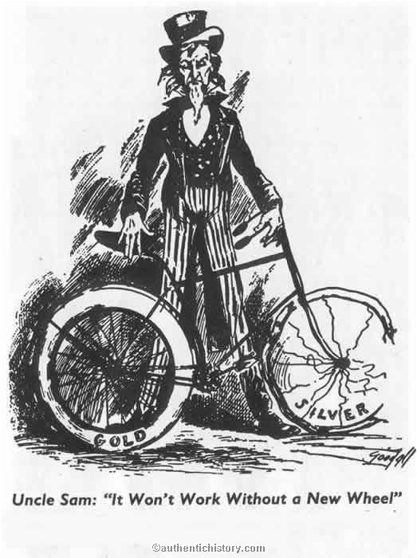

- In the political cartoon what does Uncle Sam, the man holding the bicycle, represent?

- What does the bicycle represent? Why is one wheel broken?

- Is this cartoon for silver, or against it?

- Which of the following are part of our money supply today? Quarter, One-dollar bill, Gold, Checking account, Credit card, Savings bonds.

